Phase-4 Second Project

Output Screenshots:

Adding the Budget amount

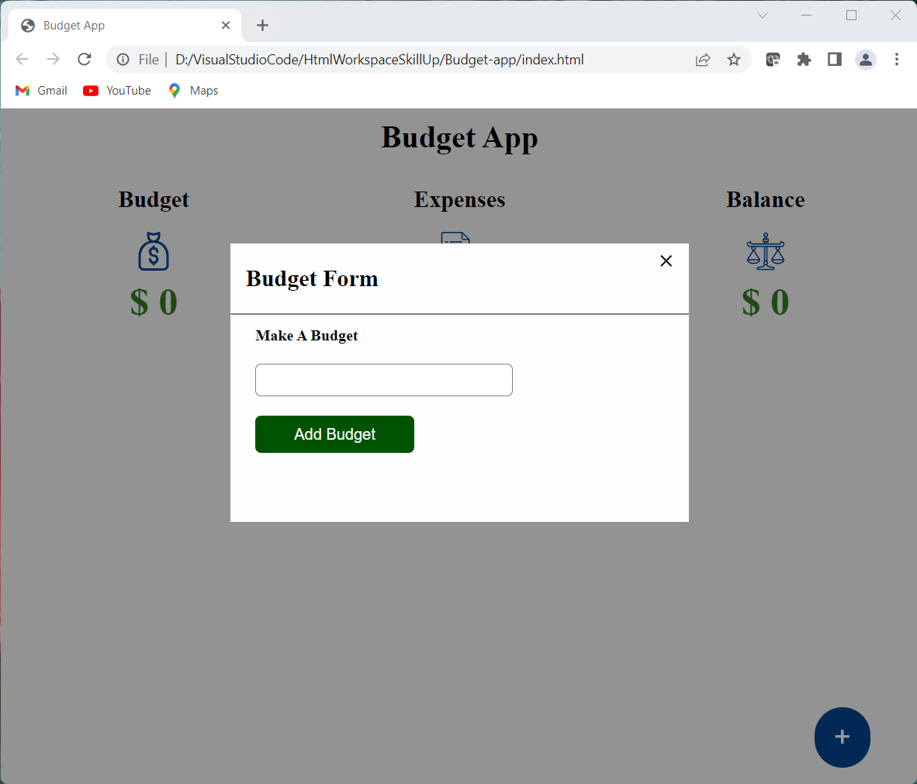

In the below Output,

One is to display the budget amount, and the other is to display the amount of the total expenses and the last is to display the balance amount after making a list of all expenses.

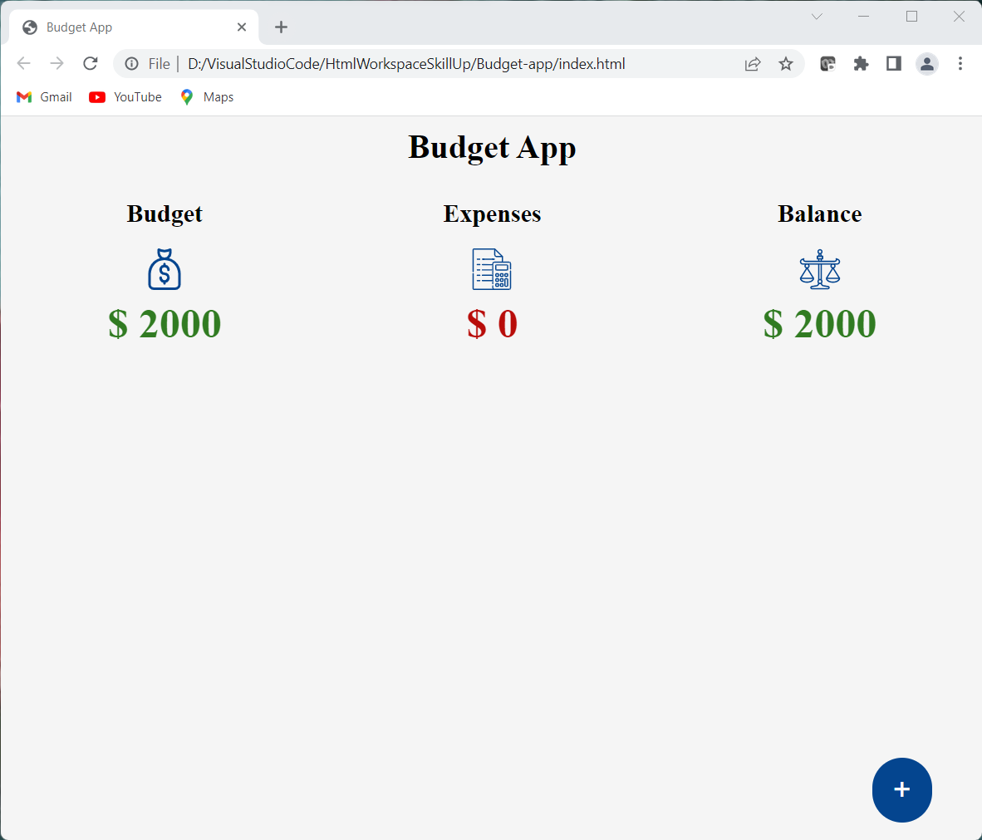

Make an expense list

We are going to create another form that takes the expense name and expense amount.

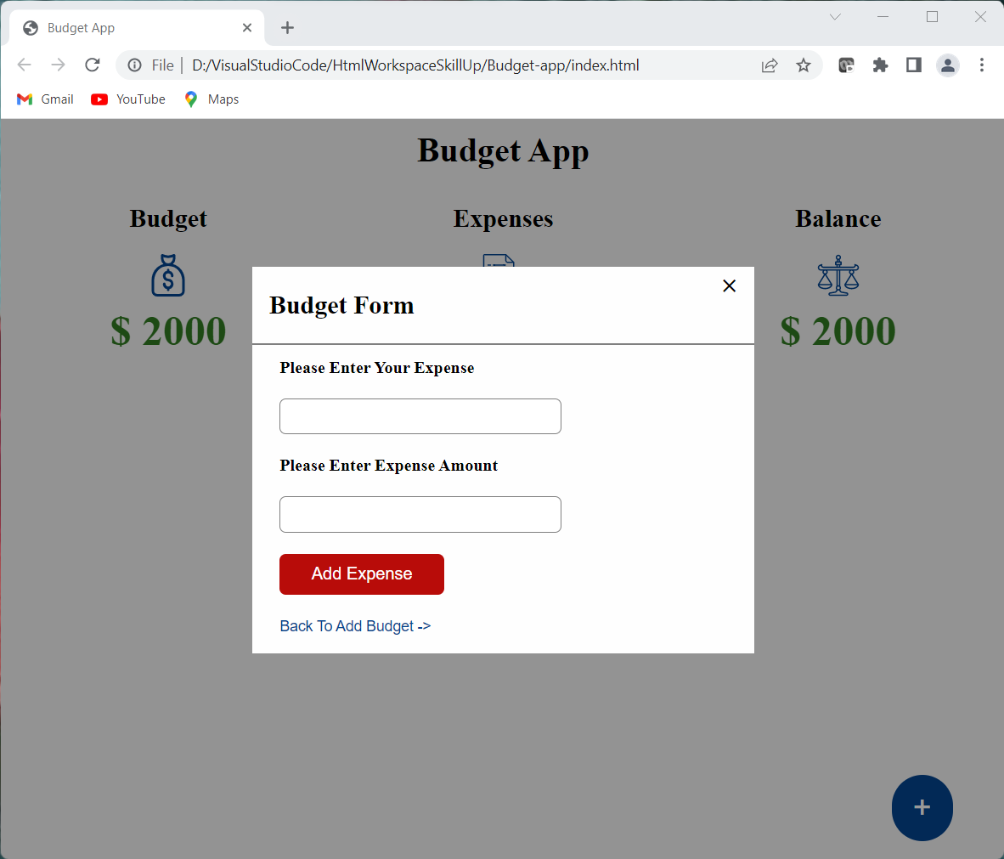

We are going to create form that takes the expense name and expense amount for Clothes.

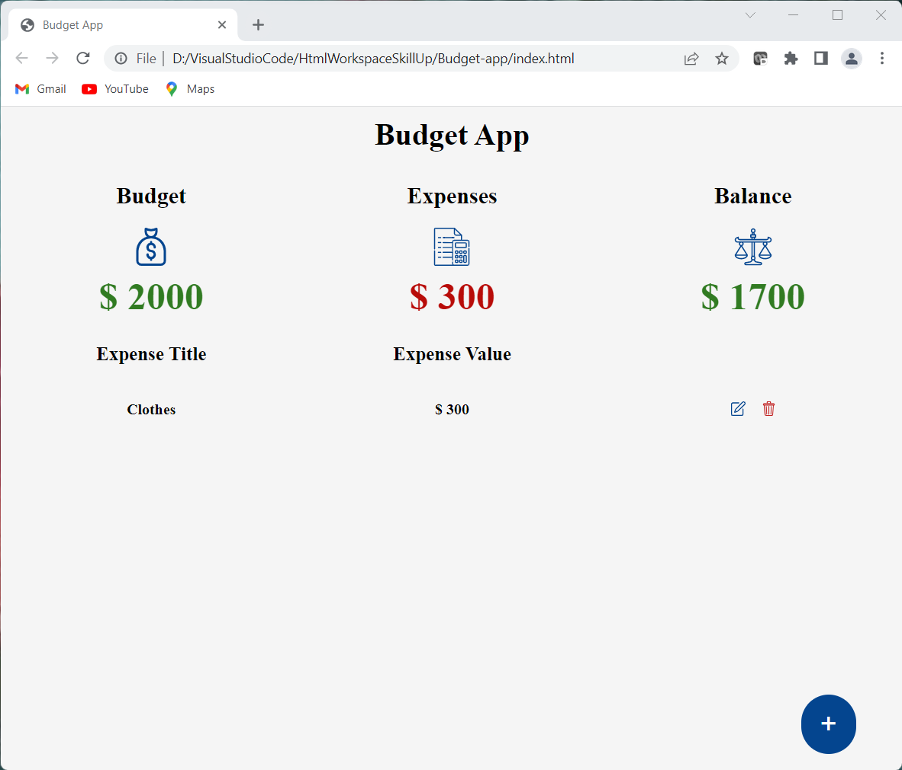

We are going to create form that takes the expense name and expense amount for Cap.

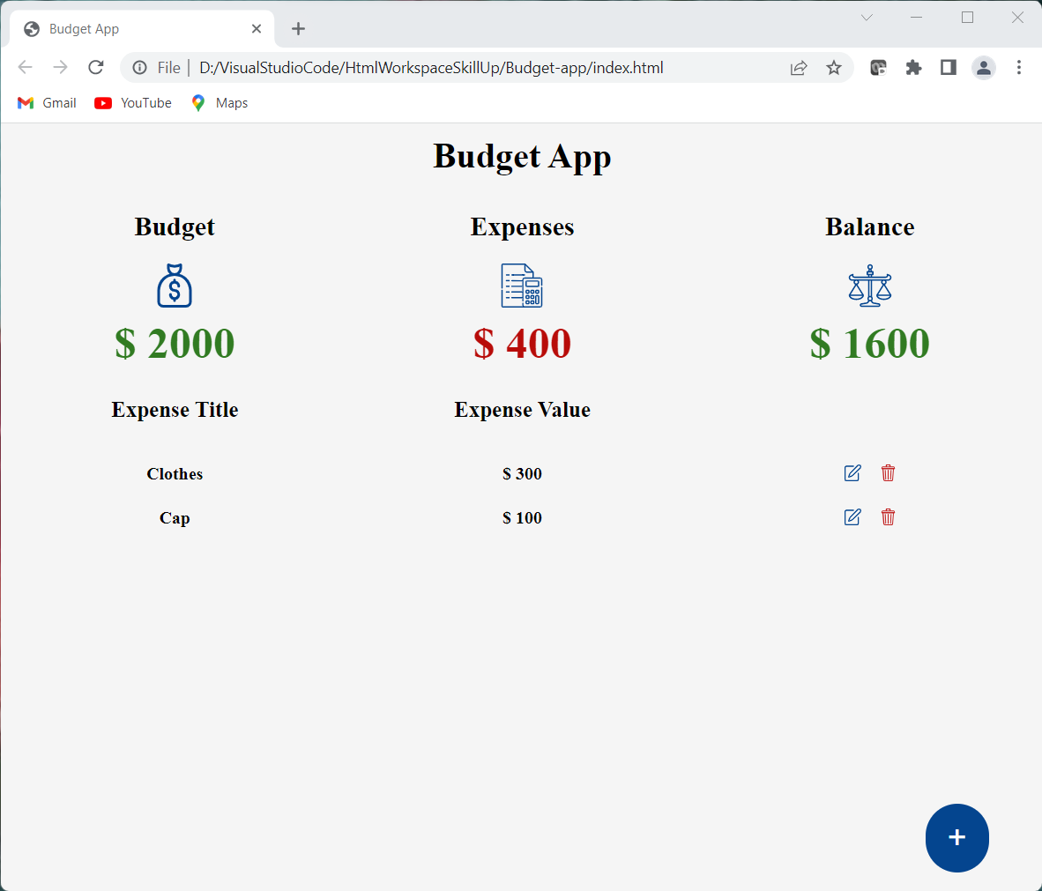

We are going to create form that takes the expense name and expense amount for Bag.

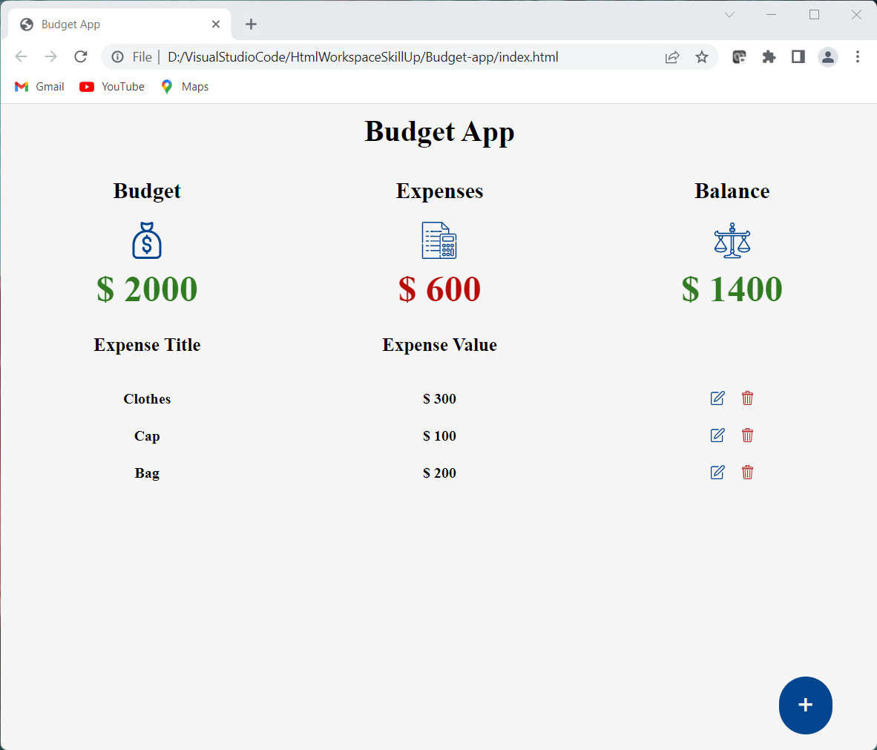

We are going to create form that takes the expense name and expense amount for Sun Shades.

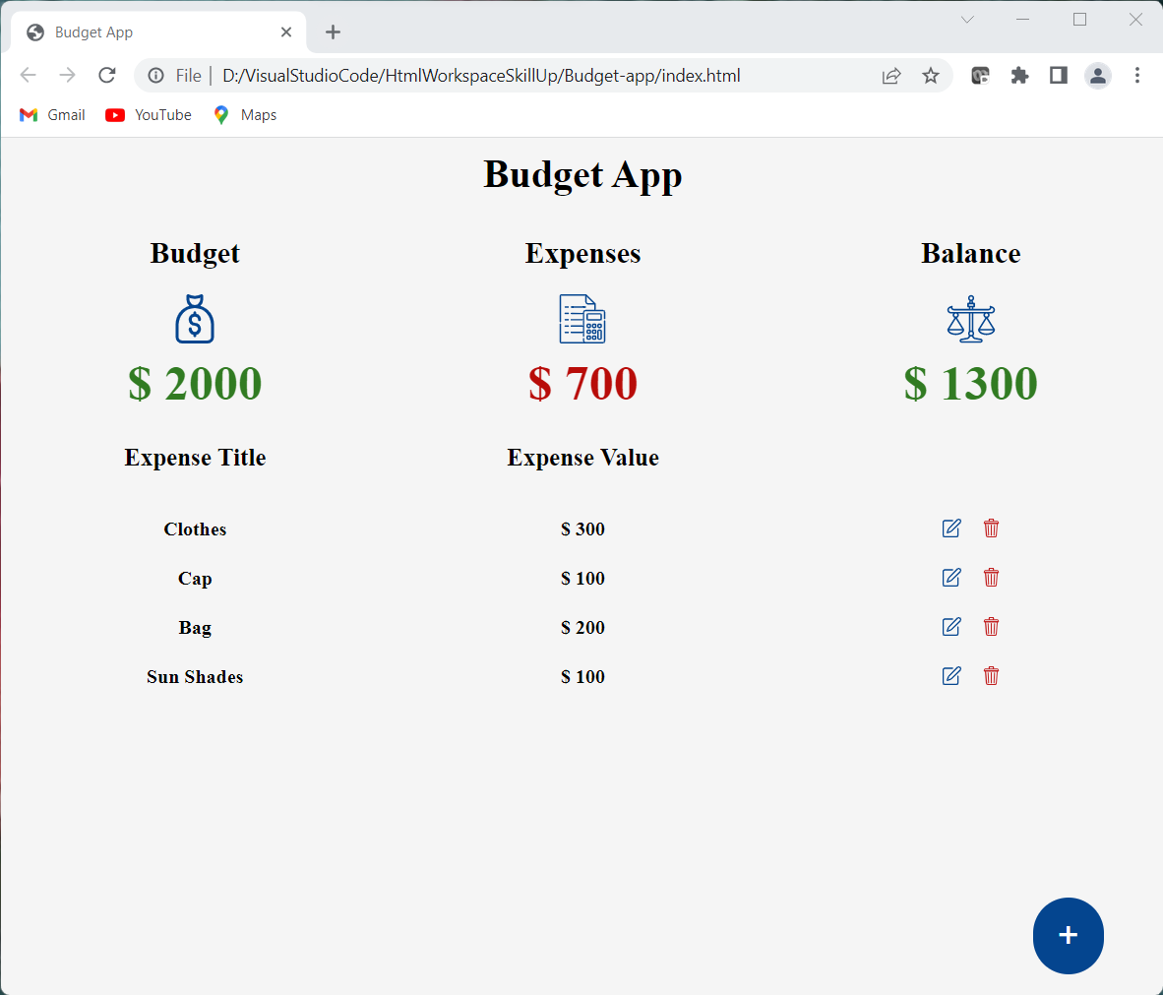

We are going to create form that takes the expense name and expense amount for Shoes.

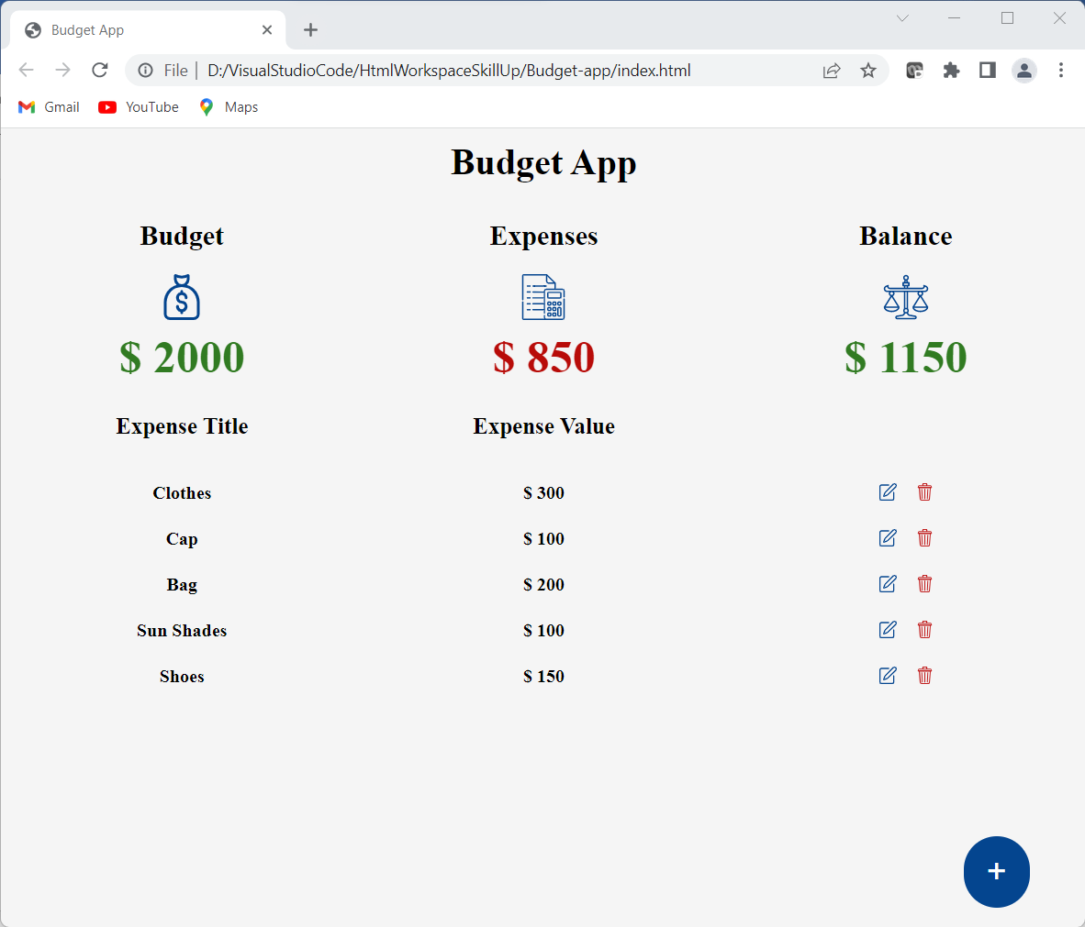

Get total balance after adding expenses

If we load our browser now and add a budget amount and also make an expense list from that budget amount, we will see the list been displayed as the image below.



Edit an expense

Let make our app more user friendly by giving our users access to be able to edit an expense after adding or making list of expenses.

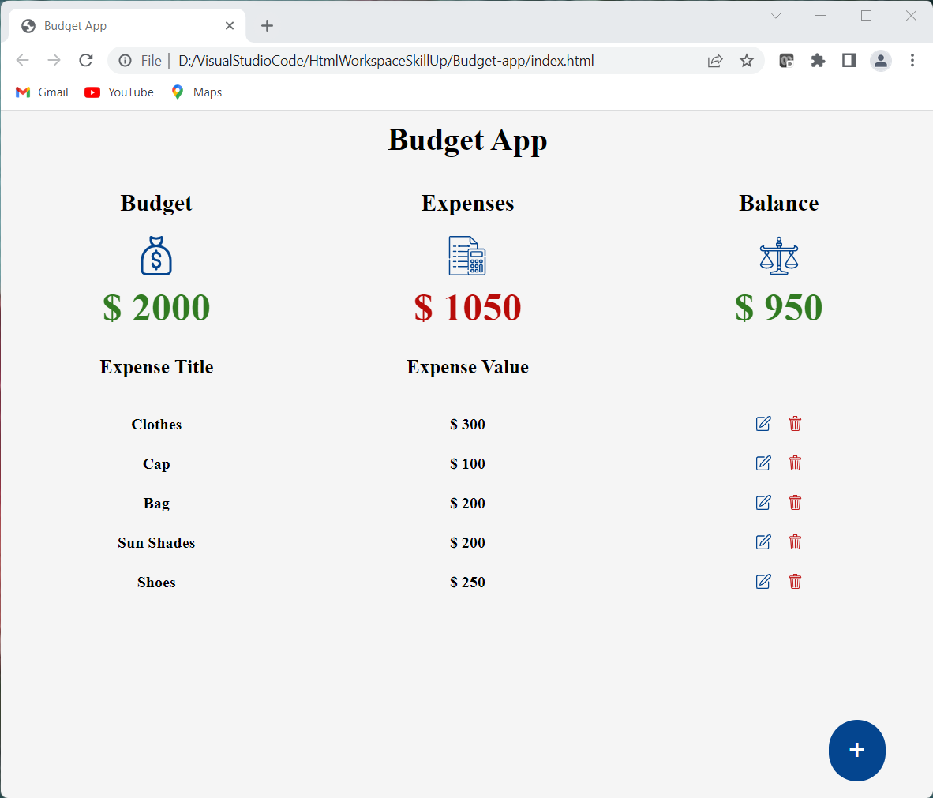

After editing Expenses for Sun Shades and Shoes the output is as shown above

Delete an expense

Let also give user access to delete an expense if user decide not to edit but to delete.

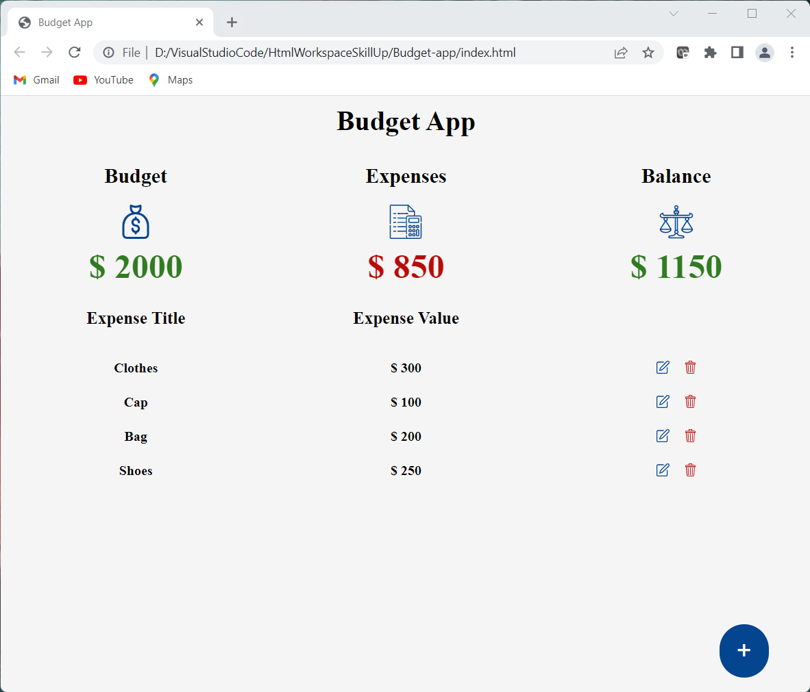

After deleting Expenses for Sun Shades, the output is as shown above.

Also after adding, updating and deleting expenses the output always shows the change in the total expenses and total remaining balance from the budget amount.

The images used in the project are

ACCOUTING

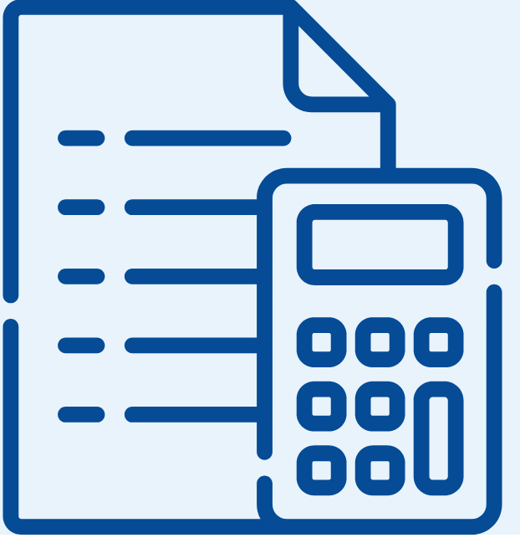

EDIT



LAW



MONEY BAG



TRASH

